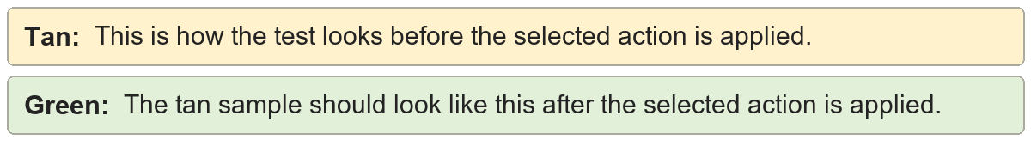
Soft returns to paragraph marks | First line
Second line
Third line
Soft returns to paragraph marks | First line
Second line
Third line

Paragraph marks to soft returns | First line
Second line
Third line
Paragraph marks to soft returns | First line
Second line
Third line

